Amrita School of Engineering, Amritapuri Campus.

19CSE213: Operating Systems

**LAB SHEET 4**

**Linux Shell Programming**

**Name: Aadithyan Raju**

**Roll No: AM.EN.U4CSE21301**

**Batch: S4 CSE D**

1. Write a shell script to generate emails in the given format and write it into a file. Your script should accept sender and recipient email id’s and subject as command line arguments.

From: [abc@domain1.com](mailto:abc@domain1.com)

To: [xx@domain.com](mailto:xx@daomain.com)

Cc: [yy@domain.com](mailto:yy@domain.com)

Subject: Subject 1

This email is generated by my shell script.

Thanks and regards

S4 CSE student

Amritapuri

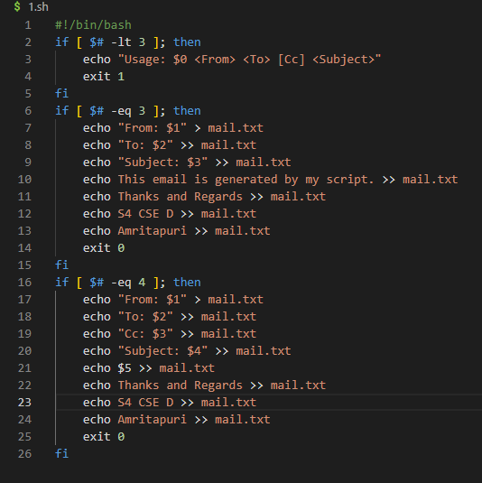

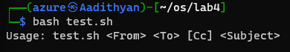



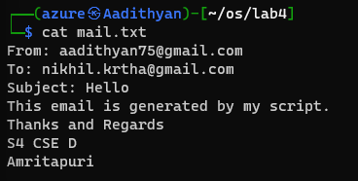

1. Modify Question 1 to allow user to enter text at the beginning of email content, by passing it as a command line argument.

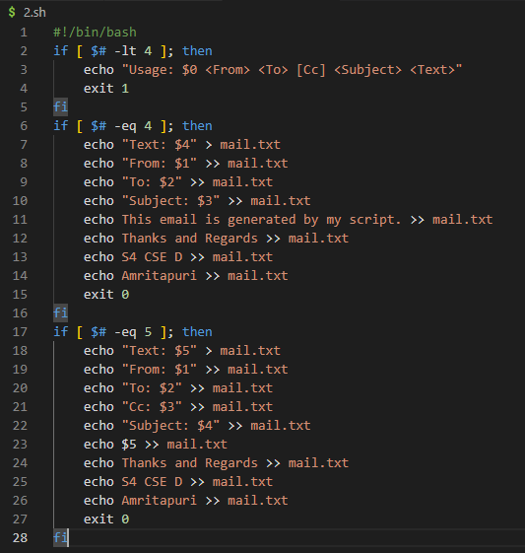

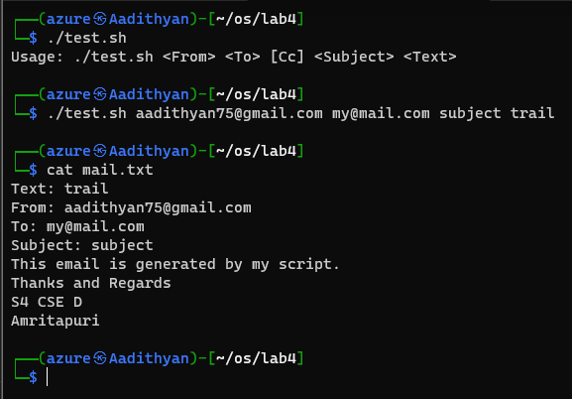

1. Write a shell script to print all the primes below a given number.

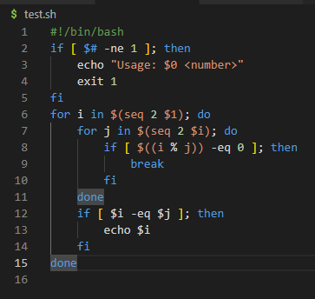

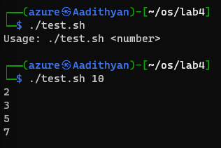

1. Write a shell script to print the first n Fibonacci numbers.

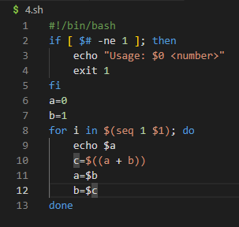

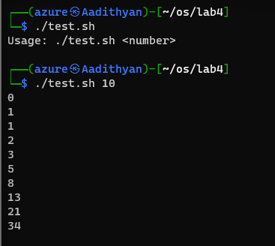

1. Write a shell script to generate a multiplication table.
   1. Interactive version: The program should accept an integer n given by the user and should print the multiplication table of that n.

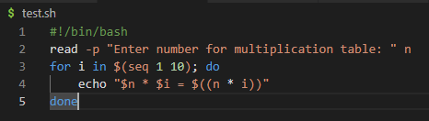

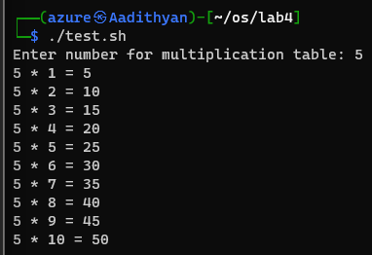

* 1. Command line arguments version: The program should take the value of n from the arguments followed by the command.

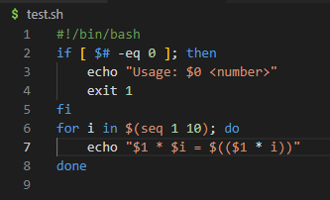

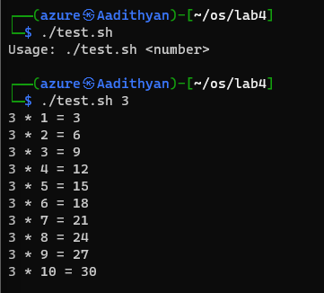

* 1. Redirection version: The value of n must be taken from a file using input redirection.

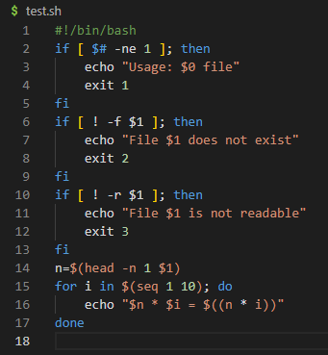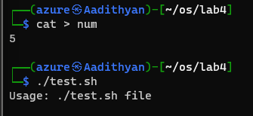

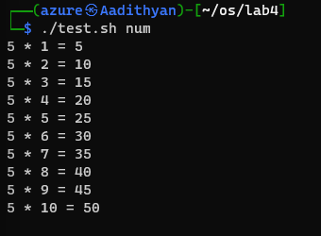

1. Using function write a shell script to find gcd of two numbers.

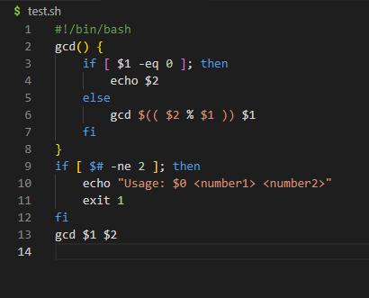

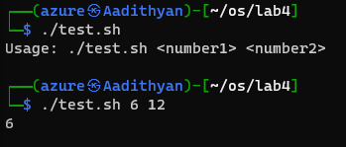

1. Using Recursion find factorial of a number

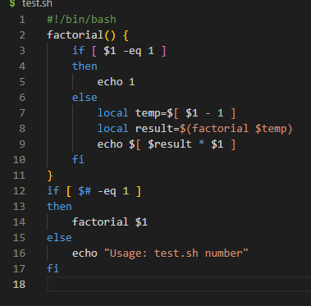

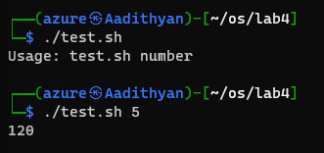

1. Write shell script to show various system configuration like:
   1. Currently logged user and his long name
   2. Current shell
   3. Home directory
   4. Operating system type
   5. Current path setting
   6. Current working directory
   7. All available shells



